Spatial Position Mapping and Synchronisation of Two Motion Capture Systems with Different Performance Characteristics

Motion Capture Systems
Vicon (Vicon Motion Systems Ltd., Oxford, UK), VIVE Ultimate Tracker (HTC, Taiwan, China).

Notation
Frame index: $i=1,…,N$.
Second-bin index: $s∈S$.
Interpolated (100 Hz) sample index: $k$.
VIVE Ultimate Tracker (VUT) position in millimetres: $p_{i}^{\text{vive}}∈R^{3}$. The default unit of VUT is metre.
Vicon position in millimetres: $p_{j}^{\text{vicon}}∈R^{3}$.
Quaternion: $q_{i}=(w_{i},x_{i},y_{i},z_{i})$, rotation matrix $R_{i}∈SO(3)$.
Local offset (optimised): $δ∈R^{3}$.
Time correction (integer frame shift): $t_{\text{corr}}∈Z$.
Coordinate remapping matrix (as implemented):
$$C=\left[\begin{matrix}-1 & 0 & 0 \\ 0 & 0 & 1 \\ 0 & 1 & 0\end{matrix}\right],C[x,y,z]^{⊤}=[-x,z,y]^{⊤}.$$

- Quaternion $→$Rotation Matrix
For unit quaternion $q=(w,x,y,z)$,
$$R(q)=\left[\begin{matrix}1-2(y^{2}+z^{2}) & 2(xy-wz) & 2(xz+wy) \\ 2(xy+wz) & 1-2(x^{2}+z^{2}) & 2(yz-wx) \\ 2(xz-wy) & 2(yz+wx) & 1-2(x^{2}+y^{2})\end{matrix}\right].$$

- Transfer Global to Local coordinates via Transposed Rotation
For each rigid body (Waist/Right shoe/Left shoe), the code computes
$$p_{i}^{\text{orig}}=R_{i}^{T} p_{i}^{\text{vive}}.$$
- Apply fixed Offset in Local Coordinates and Rotate to Global Coordinates
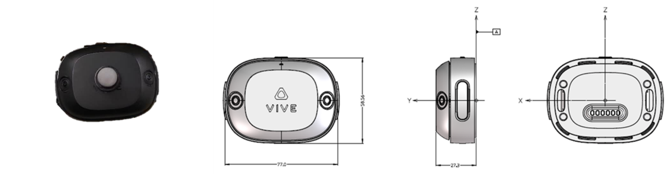
Fig. 1 Put a Vicon marker in the middle of the top of VUT (left), and the size and local coordinates of VUT (right).

Based on Fig. 1, assume the distance from the Vicon reflective marker to the origin of the VUT local coordinate system is 30mm.
3.1 Fixed vertical offset $v=[0,30,0]^{⊤}$
$$p_{i}^{\text{trans}}=R_{i}(p_{i}^{\text{orig}}+v).$$
3.2 Optimised local offset $δ$
$$p_{i}^{\text{trans}}(δ)=R_{i}(p_{i}^{\text{orig}}+δ).$$
- Per-second Resampling to 100 Hz (Piecewise Cubic Hermite Interpolating Polynomial, PCHIP)
Given timestamps $t_{i}$(seconds), define second bins
$$S=\{⌊t_{i}⌋\}∖\{\text{first bin, last bin}\},I_{s}=\{i:⌊t_{i}⌋=s\}, n_{s}=∣I_{s}∣.$$
Define normalised time grids
$$u_{m}=\frac{m-1}{n_{s}-1}, m=1,…,n_{s},{\hat{u}}_{k}=\frac{k-1}{99}, k=1,…,100.$$
For each coordinate component $p(⋅)∈\{x(⋅),y(⋅),z(⋅)\}$,
$${\hat{p}}_{s}({\hat{u}}_{k})=PCHIP⁡(\{(u_{m},p(u_{m}))\}_{m=1}^{n_{s}})({\hat{u}}_{k}),k=1,…,100.$$
Concatenate ${\hat{p}}_{k}$over all seconds $s∈S$ to form a 100 Hz series.

- Time Synchronisation (Grid Search over Integer Shifts)
Considering the potential time difference that may occur when manually collecting data simultaneously, assume the maximum time difference is 6 seconds, or 600, using Vicon Waist vertical component $z^{\text{vicon}}(⋅)$and VIVE interpolated component ${\hat{y}}^{\text{vive}}(⋅)$, select comparison indices
$$J=\{600,601,…,J_{max}\},J_{max}=min⁡(∣z^{\text{vicon}}∣, ∣{\hat{y}}^{\text{vive}}∣).$$
For candidate shift $t∈\{1,…,599\}$, define paired indices $k=j-t$. Estimate a constant vertical bias (mean difference)
$$g(t)=\frac{1}{∣J∣}\sum_{j∈J}{z^{\text{vicon}}}(j) - \frac{1}{∣J∣}\sum_{j∈J}{{\hat{y}}^{\text{vive}}}(j-t),$$
and compute the objective
$$E(t)=\sqrt{\sum_{j∈J}{(}z^{\text{vicon}}(j)-{\hat{y}}^{\text{vive}}(j-t)-g(t))^{2}}.$$
Then
$$t_{\text{corr}}=arg⁡\underset{t∈\{1,…,599\}}{min⁡}E(t).$$
- Constrained Optimisation of Local Offsets (Three VUTs)
Parameter vector
$$θ=\left[\begin{aligned}δ_{W} \\ δ_{R} \\ δ_{L}\end{aligned}\right]∈R^{9}.$$
Box constraints per marker:
$$x∈[-w/2,w/2],y∈[0,h],z∈[-l/2,l/2],$$
hence $l≤θ≤u$.
Joint objective (sum of three marker errors):
$$\underset{θ}{min⁡}F(θ)=E_{W}(δ_{W})+E_{R}(δ_{R})+E_{L}(δ_{L}),\text{s.t. }l≤θ≤u.$$
- Marker Error $E(δ)$: Kabsch-aligned 3D RMSE
After applying $δ$(Section 3) and resampling (Section 4), let ${\hat{p}}_{k}^{\text{vive}}(δ)$be the 100 Hz VUT series.
7.1 Time-aligned index pairs
$$J=\{600,…,J_{max}\},k=j-t_{\text{corr}},A=\{(j,k):j∈J, 1≤k≤K\}.$$
7.2 Coordinate remapping (as implemented)
For each $(j_{n},k_{n})∈A$,
$$v_{n}=C {\hat{p}}_{k_{n}}^{\text{vive}}(δ),u_{n}=p_{j_{n}}^{\text{vicon}}.$$
7.3 Kabsch rigid alignment
Let $N=\left|A\right|$. Centroids:
$$\overset{ˉ}{v}=\frac{1}{N}\sum_{n=1}^{N}{v_{n}},\overset{ˉ}{u}=\frac{1}{N}\sum_{n=1}^{N}{u_{n}}.$$
Centred sets:
$$V_{n}=v_{n}-\overset{ˉ}{v},U_{n}=u_{n}-\overset{ˉ}{u}.$$
Cross-covariance:
$$H=\sum_{n=1}^{N}{V_{n}}U_{n}^{⊤}.$$
Singular value decomposition (SVD):
$$H=UΣV^{⊤}.$$
Rotation with reflection correction:
$$D=diag(1,1,det⁡(VU^{⊤})),R={UDV}^{⊤}.$$
Translation:
$$t=\overset{ˉ}{u}-R\overset{ˉ}{v}.$$
Transform:
$$v_{n}^{'}=Rv_{n}+t.$$
7.4 3D RMSE
$$E(δ)=\sqrt{\frac{1}{N}\sum_{n=1}^{N}{∥}v_{n}^{'}-u_{n}∥_{2}^{2}}.$$
- Global Kabsch Alignment
Form a combined point set by stacking the synchronized trajectories of Waist, Right shoe, Left shoe:
$$P^{\text{vive}}=\{v_{n}^{W}\}∪\{v_{n}^{R}\}∪\{v_{n}^{L}\},P^{\text{vicon}}=\{u_{n}^{W}\}∪\{u_{n}^{R}\}∪\{u_{n}^{L}\}.$$
Apply the same Kabsch derivation (Section 7.3) to obtain $\left(R_{\text{all}} , t_{\text{all}}\right)$, then for any VIVE point $p$:
$$p^{'}=R_{\text{all}}p+t_{\text{all}}.$$

